Blue Buffalo Home 4 the Holidays
‘Most Heartwarming Story’ Contest

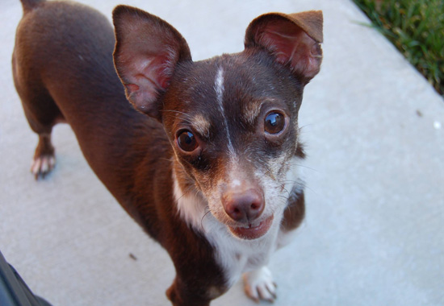
Brewster, Home 4 the Holidays’ 10 millionth pet adoption,
From I.C.A.R.E. Dog Rescue, Corona, California

One lucky animal organization, participating in this year’s Home 4 the Holidays campaign, will receive a $1,000 donation for sharing their most heartwarming pet adoption story. The adoption must take place between October 1, 2015, and January 4, 2016, to be eligible for this prize, and must include at least one high resolution photo of the pet. Be sure to enter-to-win by telling us the best stories your organization sees during the 2015 campaign. Please see below for details on how to enter.

Contest Details
Every week during the Home 4 the Holidays campaign (October 1, 2015 – January 4, 2016), participating animal organizations are encouraged to enter heartwarming adoption success stories. Submissions can be made weekly by snail mail, fax or email, and at the end of each week Helen Woodward Animal Center will select a winning story to be featured on our blog, Pause For Tails. (http://helenwoodwardanimalcenter.wordpress.com).

After the campaign ends on January 4, 2016, the weekly story submissions will be narrowed down by a panel of judges. Those finalists’ stories will then be voted on by the public and our grand prize winner will receive a $1,000 donation to their organization.

The winner will be announced in February, 2016, and will be contacted via phone or email. The winner will also be announced on Helen Woodward Animal Center’s blog.
Rules and Regulations
- Enter success stories any week (or every week!) during the campaign (October 1, 2015 – January 4, 2016). You can enter as many times as you have unique pet adoption success stories.
- Donation recipient must be a 501(c)(3) non-profit animal welfare group.
- Please include at least one, high resolution photo or image with your story.
- Stories must take place during the adoption campaign. (October 1, 2015 – January 2, 2016)

Where to Submit Your Heartwarming Stories

Email: h4th@animalcenter.org

Mail to:
c/o Home 4 the Holidays
Helen Woodward Animal Center
P.O. Box 64
Rancho Santa Fe, CA 92067

Tweet:
Tweet your story using #LightTheirWayHome!

Congratulations to 2014’s Most Heartwarming Story Winners!

We had an unprecedented outcome for 2014’s Most Heartwarming Story Contest: two Blue Buffalo Home 4 the Holidays partner organizations, Friends of Rescue and Home FurEver Rescue, each received 1,359 votes, tying them as the winners of the story contest! For their dedication and hard work both organizations will receive $1,000 for their extraordinary “tails” that showcased the resiliency and unconditional love of the pets they found homes for.
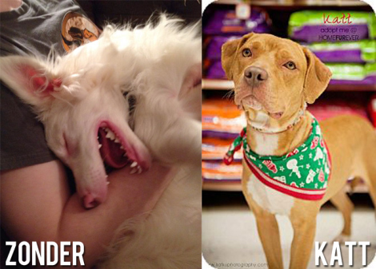
Congratulations to Zonder, from Friends of Rescue, and Katt, from Home Furever! Read their stories.

